Post-Surgery

Rehabilitation Program

Medial Patellofemoral Ligament
Reconstruction (MPFL)

Dr. Akinbiyi
Dr. Wiens

September 2019

This protocol is designed to assist you with your rehabilitation after surgery and should be followed under the direction of a physiotherapist.



Used with permission from Banff Sport Medicine.

POST SURGERY REHABILITATION PROGRAM
Progression through the phases of this rehabilitation program will vary depending on pre-operative strength and function, the extent of surgery, and commitment to the rehabilitation program.

PRINCIPLES

SURGICAL PROCEDURE
The medial patellofemoral ligament (MPFL) inserts near the medial epicondyle of the femur (inner part of the thigh bone) and into the superior half of the medial edge of the patella (inside upper knee cap). An MPFL Reconstruction creates a new ligament by replacing the torn MPFL with either a hamstring tendon autograft (patient’s) or an allograft (donor) tendon. The graft is attached using a screw in the femur bone and non-metal anchors in the knee cap.

BIOMECHANICS
The MPFL functions as a tether or leash stopping lateral movement of the knee cap during the first 30 degrees of flexion. Exercises with the knee in flexion greater than 30-45 degrees will not put strain on the MPFL Reconstruction. (The MPFL does not have a distinct function once the knee cap engages in the trochlea).

WEIGHT BEARING
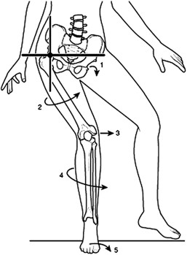
Weight bearing, without rotation or valgus, will not damage the MPFL reconstruction. Valgus knee and hip internal rotation (moving the knee inwards) during weight bearing will put the knee in a position that may stress the reconstruction and should be avoided.
Image of knee valgus and hip internal rotation movements that should be avoided after surgery (Fithian; Clin Sport Med 2010)

BRACING
The brace helps to protect the knee and leg after surgery while the quadriceps (thigh) muscle is not contracting well. Once the quadriceps are firing well enough for the patient to do a straight leg raise with no quadriceps lag, the patient can wean into the Patellar Stabilizing Brace (PSB – See Page 15 for examples). The other
consideration for initiating the PSB will be the amount of swelling and tenderness around the incisions because the neoprene sleeve is tight. The brace should be used during activity until full quadriceps strength and function is restored. The brace does not need to be used during activities that are not prone to knee valgus or hip internal rotation.

RANGE OF MOTION
Range of motion exercises will not stretch the MPFL graft. A properly positioned and securely fixed graft can withstand the physiologic loads placed on it during range of motion exercises. Full extension is usually achieved soon after surgery. Flexion may be limited by pain caused the surgical dissection around the medial epicondyle of the femur.

STRENGTHENING
MPFL reconstruction causes significant quadriceps muscle inhibition (weakness) post-operatively. Early rehabilitation must focus on regaining quadriceps control and strength. Straight-line quadriceps strengthening exercises will not harm the graft. An electrical muscle stimulation (EMS) machine can increase strength gains when combined with your own voluntary muscle contraction. We highly

recommend that you use EMS at all phases of this rehabilitation protocol. EMS machines can be purchased from medical equipment stores, physiotherapy clinics, or from the BSM online shop (www.banffsportmed.ca). Most third-party insurance companies cover the cost of the EMS machine.

CORE & HIP STRENGTHENING
These exercises are very important for good function after surgery and can be started in the first week after surgery.

PHYSIOTHERAPY
Rehabilitation after MPFL reconstruction requires careful monitoring by a physiotherapist. There is no time restriction for the progression of phases. Progression will be decided by the physiotherapist based on each patient’s clinical progress. Each patient should have a frank discussion with their physiotherapist about how to best utilize the physiotherapy visits that they can afford. Patients will generally need physiotherapy care and guidance for 6 - 12 months after surgery.

RETURN TO SPORT
Return to sport is based on progression to sport specific activities and depends on quadriceps, hip and core strength and control. The MPFL reconstruction will be well healed by the time this strength and control is obtained. Most patients take between 6 months - 2 years to rehabilitate well enough to return to sport, although some patients may return slightly earlier with dedication to their rehabilitation programme.

COLD THERAPY
Cold therapy is the use of ice or cold to reduce pain, inflammation, swelling and spasm after surgery. Cold therapy can be applied with a bag of ice, an ice pack, gel pack, or by using a specialized Cold Therapy Unit. Research has shown that cold therapy decreases pain, inflammation, swelling, blood loss, and narcotic (pain medication) use after surgery.
You should use cold therapy a minimum of 5 times per day for 20 minutes each for the first 5-7 days after surgery. It is essential that you protect your skin from the cold therapy product using a cloth or towel. If you are using a Cold Therapy Unit it is possible to safely keep the cold pads on for longer periods of time. To get the best results and prevent skin injury, you should always carefully follow the instructions that come with the Cold Therapy Unit. After the first 7 days, cold therapy should continue at least 3 times per day when any swelling remains in the knee.

PHASE 1: Early Post-operative Phase
This is the initial recovery phase and it normally lasts 1 - 3 weeks. In the first week you should rest and elevate your leg for a significant amount of the time.

GOALS

Control inflammation and swelling
- Range of motion exercises within pain limits, i.e. active and active-assisted knee flexion (bending) and extension (straightening)
- Quadriceps muscles activation
- Hip strengthening

BRACE
A brace will be placed on your leg after surgery and it should be worn at all times when you are walking and sleeping. You may remove the brace to ice your knee or if you are resting quietly.

WEIGHT BEARING
Use your crutches to weight bear by putting about half of your weight through your operative leg. With your crutches, try to walk using a normal “heel-toe” pattern. Your progression to full weight bearing will depend on swelling, pain, and quadriceps control. Increase to full weight bearing as soon as you are able to tolerate.

COLD THERAPY & ELEVATION
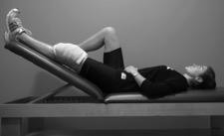
A Cold Therapy Unit or an ice pack should be applied immediately after surgery and used for at least 20 minutes every other hour while you are awake and especially after exercises. Your surgical leg should be elevated with your knee straight when applying cold therapy or resting.

EXERCISES

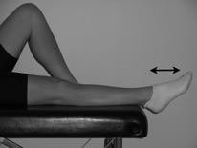
Ankle Pumps:
  - The foot and ankle should be actively “pumped” up and down 10-20 times every hour.

Range of Motion:
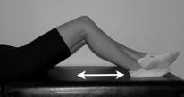
  - Flexion: In lying, bend your knee by sliding your heel towards your buttocks. You can use your other leg to help you as needed. Perform up to 20 times; repeat 2 - 3 times daily.

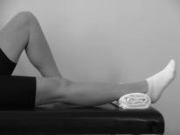
  - Extension: In lying, place a roll beneath your ankle to passively (i.e. allow gravity), stretch your knee into extension. Start with 2 minutes at a time and increase as tolerated up to 5 minutes. Perform 2 or 3 times daily. It is very important in this phase to work on straightening your knee.

Strengthening:
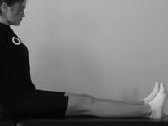
  - Quadriceps Contraction: In sitting with your knee straight and leg supported, tighten your thigh muscle by pushing your leg downwards. Focus on tightening the muscle and avoid lifting your leg from the hip. Perform exercise 5 -10 times holding each contraction for 5 secs. Progress to 30 times holding each contraction for 10 secs, resting for 5 secs in between reps. The use of EMS is recommended for this exercise.
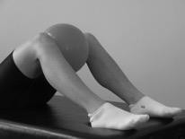
  - Hip Adduction: In lying with your knees bent as shown, squeeze a soft ball or a pillow between your knees. Perform exercise 5 - 10 times holding each contraction for 5 seconds. Progress to 30 times holding each contraction for 10 - 15 secs, resting for 5 secs between reps.

** Perform all exercises 2-3 times per day to build your strength and endurance

ALSO CONSIDER
  - Hip strengthening as tolerated
  - Straight leg raises, Quads over roll with EMS
  - Other ROM exercises as tolerated (heel slides on wall/passive flexion in sitting using other leg to push)
  - Stationary bike
  - Resisted ankle exercises in sitting using rubber tubing

REQUIREMENTS FOR PROGRESSION TO PHASE 2

Ability to activate quadriceps (specifically VMO)
    - Pain levels managed to enable exercise progression
    - Full knee extension
    - Knee flexion ≥ 60°

PHASE 2: Quads Activation and Core Stability
This is the initial muscle strengthening phase and it normally lasts from 3-12 weeks. This phase emphasizes progressive activation of the quadriceps muscles and significant core strengthening.

GOALS

Manage pain and swelling
- Range of Motion: 0° to ≥ 90° by end of 6th week post-operative
- Good quadriceps muscle contraction; able to perform a straight leg raise
- Full weight bearing with crutches wearing unlocked or patella stabilizing brace
- Include stationary bike in daily rehabilitation
- Focus on quadriceps activation (using EMS) and hip strength

BRACE
The brace placed on your leg after surgery may be taken off at night for sleeping. As your ability to contract your quadriceps improves, you can start to wean into the Patellar Stabilizing Brace (PSB). This is usually 4 - 6 weeks after surgery. A brace should be worn whenever you are walking outside the house.

WEIGHT BEARING
In order to stop using crutches, you must be able to walk without a limp while using crutches (i.e. you must be able to fully weight bear on the operated leg without compensation). Continue to use your crutches until you can fully weight bear and have good quadriceps control. If you still need support to walk normally, you may use one crutch or a cane, depending on the recommendation of your surgeon. Your physiotherapist can also help guide you through this process. You should wean off using the crutches by the end of this phase.

COLD THERAPY & ELEVATION
Manage knee swelling by continuing to use cold therapy and elevation, particularly after exercise.

EXERCISES

Range of Motion:
  - Progress flexion using active, active-assisted and passive exercises.

Strengthening:
  - 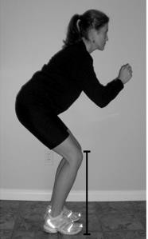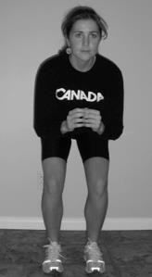Quadriceps: Slowly squat with equal weight on each leg. Bend your knees from 0° to a maximum of 90° of flexion, making sure your knees do not move beyond your toes. Start with one set of 10, holding each squat for 5 secs and increase the number of reps as your strength increases, up to 30 reps x 15 sec holds. EMS should be used with this exercise with the ‘contraction’ time at least double the ‘rest’ time.

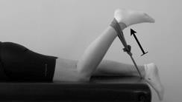
  - Hamstrings: Lying on your stomach, place a resistance band around your ankle and also have it attached to an anchor point as shown. Bend your knee slowly against the resistance of the band pulling your foot towards your buttock. Start with 1 set of 10 reps and increase to 3 sets of 15 reps.
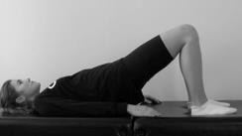
  - Gluteals: In lying with your knees bent and your arms by your sides, squeeze your buttocks and lift up to create a bridge. Keep equal weight on each leg and straight alignment from your shoulders to your knees. Be careful not to push down on your neck or shoulders - use your buttocks to do the work.
Start with one set of 10, holding each lift for 5 secs. Increase the number of
reps as your strength increases. Once you can complete 20 reps holding for 10 secs each, change to single leg bridges.
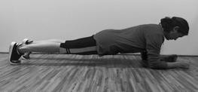
  - Planks: Place the forearms on the ground with the elbows aligned below the shoulders, and arms parallel to the body at about shoulder-width distance. Engage your core and glute muscles and lift the hips up off the ground. Start with one set of 10, holding each lift for 15 secs. Increase the holding time as your strength increases.
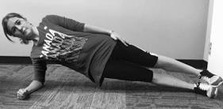
  - Side Planks: Lie on one side with the legs stacked on top of one another then prop the body up on the hand or elbow while keeping the feet stacked. Start with one set of 10 repetitions on each side, holding each lift for 15 secs. Increase the holding time as your strength increases.
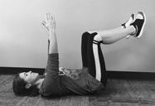
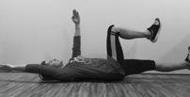
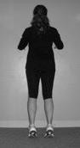
  - Dead Bugs: Lie flat on your back with your hands extended above you toward the ceiling. Bend your knees in a 90-degree angle and raise your thighs until they are perpendicular to the floor. Now deeply exhale and engage your abs to bring your ribcage down and flatten you back onto the floor. Slowly lower the right arm and the left leg down towards the floor at the same time. Lower them until just before your lower back starts to arch off the ground. Breathe out slowly as your lower your arm and leg, and then slowly return to the starting position while breathing in again. Alternate sides. Start with one set of 10, holding each lift for 5 secs. Increase the number of reps as your strength increases.

Calf Raises:
Both legs: Start with feet shoulder width apart and toes pointed straight ahead, and raise up onto your toes. Start with one set of 10 reps, holding each raise for 5 secs. Increase the number of reps up to 30 with 5 sec hold. Start by using support at a wall or table and progress to no support as able.
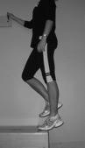
Single leg: Start on one leg with toes pointed straight ahead, and raise up onto your toes. Start with one set of 10 reps, holding each raise for 5 secs. Increase the number of reps up to 30 with 5 secs hold. Start by using support at a wall or table and progress to no support as able.

Proprioception/Balance:
  - Weight Shifting: Stand without your brace on, slowly shift weight from your non-operated to your operated leg. Slowly increase the amount of weight supported through your operated leg.
  - Single-leg Stance: Once you can comfortably shift all your weight onto your surgical leg progress to balancing. Stand on your non-operative leg first and hold for 10 seconds; then stand for 5 secs on your operative leg. Slowly increase the amount of time you can balance, up to 30 seconds, 5 times each leg.

ALSO CONSIDER
  - Isometric exercises (quadriceps, hamstrings, hip flexors/extensors/rotators)
  - Adductors/abductor with resistance tubing
  - Clam shells
  - Double leg squats with ball squeeze
  - Abdominal and core strengthening (i.e. curl-ups, obliques, transversus abdominis, physio ball and Pilates)

REQUIREMENTS FOR PROGRESSION TO PHASE 3

Straight leg raise with no quadriceps lag
    - Good core strength
    - Double leg squat with good motor control
    - Single leg bridges 10 repetitions x 10 sec hold each

PHASE 3: Strength and Control
This is a progressive strengthening and balance phase and normally lasts from 9 – 18 weeks but may take up to 6 months to master.

GOALS

Full range of motion
- Walking without crutches normal gait, wearing patellar stabilizing brace
- Improve proprioception and balance.
- Aerobic activity 20 - 30 minutes per day.
- Increase quadriceps, hamstrings, gluteal and core strength

BRACE
You should be in the patellar stabilizing brace for all at risk activities. You do not need to wear the brace in safe environments such as at home or while sleeping.

WEIGHT BEARING
You should be full weight bearing without walking aids at this phase.

COLD THERAPY & ELEVATION
Manage knee swelling by continuing to use cold therapy and elevation, particularly after exercise.

EXERCISES
- 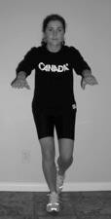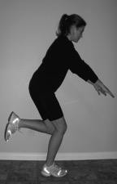Range of Motion: Should be full at this stage.

Strengthening:
  - Single Leg Squats: Initially use a chair or railing for support. Standing on one leg, slowly squat bending your knee from 0° to a maximum of 90°, making sure your knee does not move beyond your toes. Start with one set of 10, holding each squat for 5 secs and increase the number of reps as your strength increases, up to 30 reps x 15 sec holds.

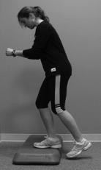
Step-ups:
Do graduated heights, starting at 4" and increasing to 8".
Stand in front of a stair or stepping stool and place one foot on the step in front of you. Rise up onto the step by shifting all of your weight onto this leg and tighten your quadriceps muscles. Put all of your weight through this leg and do not step up onto the step with your other leg. Start with one set of 10, holding at the top of the step-up for 5 secs. Increase the number of reps up to 20 reps with 15 sec holds on each leg.

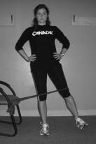
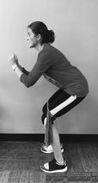
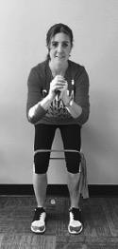
  - Squats with Rubber Band: Stand with legs shoulder width apart with a resistance band around your thighs just above your knees. Slowly squat with equal weight on each leg. Bend your knees from 0° to a maximum of 90° of flexion, making sure your knees do not move beyond your toes. The rubber band will push your knees into internal rotation (inwards), so make sure the patella is aligned with the second toe the whole time. Start with one set of 10 reps, holding each squat for 5 secs and increase the number of reps as your strength increases, up to 30 reps x 15 secs hold. EMS is recommended for this exercise with the ‘contraction’ time at least double the ‘rest’ time.
  - Hip Abduction: With a resistance band around your outside thigh just above your knee, lift your leg to place slight tension on the band. Move this leg sideways slowly against the resistance of the band using the muscles in your buttock and your hip. Start with 1 set of 10 reps and increase to 3 sets of 15 reps.

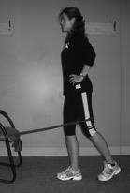
  - Hip Extension: Stand with legs shoulder width apart with a resistance band around one of your thighs just above your knee. Extend your leg to place slight tension on the resistance band. Move the leg backwards slowly against the resistance of the band using the muscles in your buttock and the back of your thigh. Start with 1 set of 10 reps and increase to 3 sets of 15 reps.
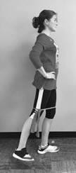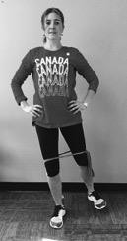IMPORTANT: if you had a hamstring graft you should not perform this exercise until 6 weeks post op.
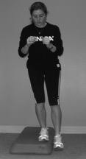
  - Combination: Hip extension + external rotation + abduction: In standing with legs hip width apart and feet straight forwards, tie a resistance band around your thighs as shown. Move your leg outwards and backwards in a 45-degree angle with your toes slightly pointing out. Keep your pelvis square and still, so you don’t compensate with your back muscles. Engage your “back pocket muscles” as you perform the movement. Start with one set of 10, holding each movement for 5 secs. Increase the number of reps as your strength increases.
  - Step-downs: Do graduated heights, starting at 4" and increasing to 8". Start with one leg standing on the step and slowly bend your knee to lower your other leg to lightly touch the floor. Keep all of your weight through the leg that is on the step. Start with one set of 10, holding at the bottom of the step-down for 5 secs. Increase the number of reps as your strength increases, up to 20 reps with 15 sec holds on each leg.

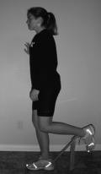
  - Standing Hamstring Curls: Attach one end of the tubing securely at heel height and attach the other end to your ankle. Standing with both knees slightly bent, slowly contract your hamstring muscles to bend your knee. Slowly return to your starting position; repeat 15 times on each leg. Increase the resistance of your band and the number of repetitions as you become stronger. Keep a check on your posture and contract your core muscles for stability while you are bending your knee.

  - 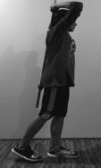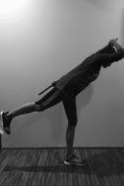Single Leg Dead Lift With Pole: Stand on your non-operated leg first and hold the pole behind your back to keep it in a neutral position. Keep the supporting knee still. Flex forward from the hips, allowing the opposite hip to extend while keeping the spine neutral and the hips facing forward. The foot that goes up should be pointed down to help prevent hip rotation. Hinge forward through the hips only as far as you are able to maintain a neutral spine, keeping the shoulders and hips parallel to the floor.
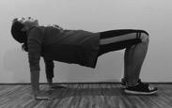
  - Reverse Bridge: Place your palms, with fingers spread wide, on the floor slightly behind and outside your hips in a sitting position. Press into your palms, and lift your hips and torso toward the ceiling, trying to keep a straight line from head to knees, which will be bent at 90 degrees. Hold for 10 seconds and slowly lower the hips back down. Start with one set of 10. Increase the number of reps as your strength increases, up to 20 reps with 15 sec hold.

Proprioception:
  - Double leg squats on an unstable surface (thick carpet → camping mattress → foam pillow → balance disc → BOSU)
  - Single leg stance on an unstable surface (thick carpet → camping mattress → foam pillow → balance disc → BOSU)
  - Wobble board balance and weight shift activities
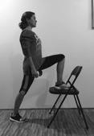
  - Single leg calf raises +/- mini squat

Stretches:
  - Hip Flexors: Stand with good posture with left leg up on chair. Tuck your tailbone under. Push your hips forward until you feel a stretch in front of your right thigh. Avoid arching through the lower back.
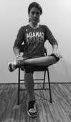
  - Hip Internal Rotators: To stretch the left side, cross your left leg over the right so that your left ankle is lying across your right thigh. Put your left hand on your left thigh and gently press down until you feel resistance. Then tilt forward at the hips slowly as you exhale. Remember to keep your chest up and your back straight. Don't allow yourself to hunch forward. Repeat with the other leg. Hold each stretch for at least 30 seconds and repeat 3 times.
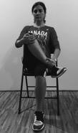
  - Hip External Rotators: To stretch the right side, cross your right leg over your left so that your right ankle rests on your left knee. Use your hands to grab hold of your right knee and pull it gently toward the opposite shoulder. You should feel the stretch in your buttocks and hips. Repeat with the other leg. Hold each stretch for at least 30 seconds and repeat 3 times.

ALSO CONSIDER
  - Hip adduction (open chain) in standing; progress to resistance with tubing or weights
  - Lunges - forwards/backwards
  - Abdominal and core strengthening (i.e. curl-ups, obliques, transversus abdominis, physio ball and Pilates)
  - Hamstring curls in lying with a physio ball
  - Open kinetic chain weight-training exercises (leg press, knee extension, hamstring curls, hip strengthening with pulleys)
  - Walking/hiking/jogging/cycling as tolerated
  - Pool: flutter kick, easy jogging in waist deep water and running in deep water with aqua-belt

REQUIREMENTS FOR PROGRESSION TO PHASE 4

Improved strength and endurance
    - Ability to demonstrate good core control and posture in single leg stance activities
    - Must be able to perform a controlled single leg squat to 70° before commencing plyometrics

PHASE 4: Sport Readiness
This phase begins as early as 3 months after surgery but usually starts around 18 weeks and may last up to 2 years. This phase focuses on improving agility and strength through plyometric exercises, and return to functional activities including sports.

GOALS

Improve proprioception and balance
- Increase aerobic endurance
- Maximize quadriceps, hamstrings, gluteal and core strength with functional exercises
- Accurately perform plyometric drills
- Training with sport specific drills

COLD THERAPY & ELEVATION
Manage knee swelling by continuing to use cold therapy and elevation, particularly after exercise.

EXERCISES

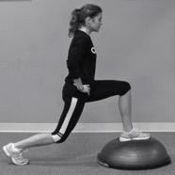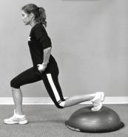Proprioception:
  - Lunges on BOSU: Step forward/back and lunge as shown. Control the descent ensuring your knee that is forward does not move beyond your toes. Start with 1 set of 10, holding each lunge for 5 secs. Increase the number of reps as your strength increases up to 3 sets of 10 on each leg.
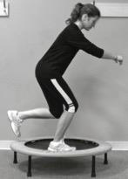
  - Single Leg Squats On Trampoline: Standing on one leg, slowly squat bending your knee from 0° to a maximum of 90°, making sure your knee does not move beyond your toes. Start with one set of 10, holding each squat for 5 secs and increase the number of reps as your strength increases, up to 20 reps x 15 sec holds on each leg.

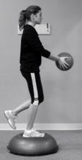
  - Single Leg Stance With Ball Toss: Standing on one leg on a BOSU or other unstable surface (i.e. foam block), toss and catch a light ball against a wall. Start with 2 sets of 15 tosses on each leg and increase as strength and balance improve.

Dynamic Core:
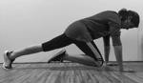
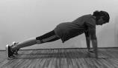
  - Mountain Climber: Assume a press up position so your hands are directly under your chest at shoulder width apart with straight arms. Your body should form a straight line from your shoulders to your ankles. Lift your right foot off the floor and slowly raise your knee as close to your chest as you can. Return to the starting position and repeat with your left leg. Start with 1 set of 10. Increase the number of reps as your strength increases up to 3 sets of 15.
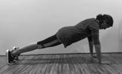
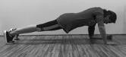
  - Ups and Downs: Assume a press up position so your hands are directly under your chest at shoulder width apart with straight arms. Your body should form a straight line from your shoulders to your ankles. Lift your left hand off the ground and then place your left forearm on the ground where your hand just was. Do the same with your right arm. Now pick your right forearm off the ground and put your palm back on the ground. Follow again with your left arm. This completes one repetition. Start with 1 set of 10. Increase the number of reps as your strength increases up to 3 sets of 10.

Plyometrics:
Patient must be able to perform a controlled single leg squat to 70° before commencing plyometric exercises.

  - Agility Jumping: start with straight-line jumping, backward/forward/side-to-side and progress to diagonals and combined patterns. Once speed and agility are good with jumping, progress through activities using single-leg hopping on each leg.

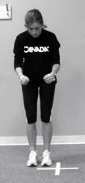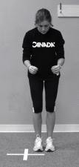 | 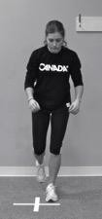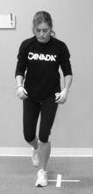
Agility Jumping | Agility Hopping
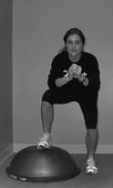
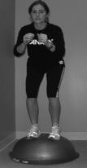
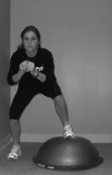
  - Side to Side Jump Steps on the BOSU: Perform quick steps in both directions over BOSU. Start with 1 set of 10 steps in both directions and progress to 3 sets of 15 steps in both directions as your strength increases.

  - Jumping: tuck jumps, box jumps, long jumps
  - Hopping: single-leg hop (distance), 6m timed hop, triple hop (distance), zig-zag hops

Agility:
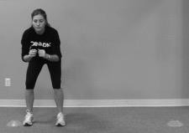
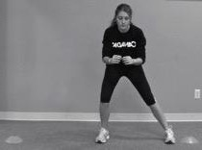
  - Quick Lateral shuttles from cone to cone
  - Skipping rope - double and single leg
  - Grapevine/Cariocas
  - Figure 8's around cones
  - Agility Ladder

Running Drills:
  - Shuttle sprints, stop and go drills
  - Zig-zag running, sideways and backwards drills
  - Sprinting with cutting and pivoting drills

Sport-specific Drills:
  - Basketball: lay-up drills, lateral shuttle runs while throwing/catching ball off wall, run-pivot-vertical jump, dodging drills, defence drills (running/jumping backwards)
  - Soccer: dribble around cones, shooting drills, defence drills, lateral shuttle runs while kicking ball off wall, tackling drills
  - Football/Rugby: dodging/deking drills, running and throwing drills (all directions), defence tackling drills
  - Hockey: skating figures, stick handling drills, shooting drills, deking drills

ALSO CONSIDER
  - Open kinetic chain weight-training exercises (leg press, knee extension, hamstring curls, hip strengthening with pulleys)
  - Wobble-board balance activities +/- perturbation (throwing/catching ball, raising arms)
  - Box hops (up/down starting with 6” block)
  - Tiptoe and heel walking along a line → progress to tiptoe and heel skipping
  - Rocker board lunges (forwards/backwards)
  - Single-leg calf raises + mini squat
  - Forward and Sideways leg swings (special attention to core stability)
  - Abdominal and core strengthening (i.e. curl-ups, obliques, transversus abdominis, physio ball and Pilates)

NOTE: If you have specific questions about how to train for returning to your sport please ask your surgeon at your 6 and/or 12-month post-operative appointment.
Examples of Patellar Stabilizing Brace:

DONJOY Lateral J Patella Knee Brace BREG Lateral Stabilizer Soft Knee Brace

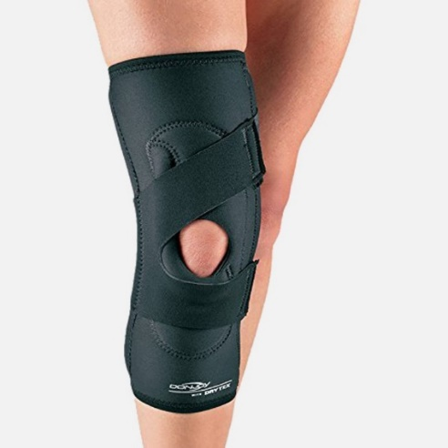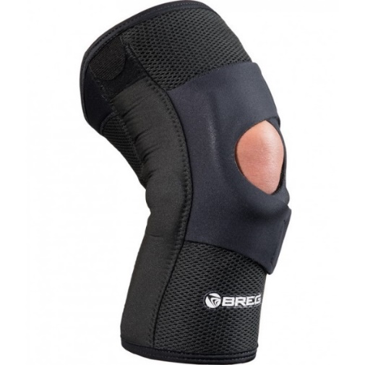

Used with permission from Banff Sport Medicine.
Please contact our office for more information:

Banff Sport Medicine
PO Box 1300 Banff, Alberta, Canada T1L 1B3 Phone: 403-760-2897 Ext 6
Fax: 403-760-8234
sarah@banffsportmed.ca www.banffsportmed.ca

