
Dr. Akinbiyi
Queen Elizabeth II Hospital
_______________________________________________________________________________
EXERCISES AFTER NECK SURGERY
For Cervical Fusion with CSLP Plate ONLY
(Beginning 2 weeks after surgery)

- Perform only those exercises indicated and instructed by your physiotherapist
- Perform all exercises within your pain limits. If the exercises increase pain, stop the exercise, and try again the next day. If you are unable to do the exercises due to pain, consult your healthcare provider (e.g. surgeon or physiotherapist)
- If you experience new numbness, tingling, or increased weakness, consult your healthcare provider immediately
- Please continue to wear your collar for all other activity and follow your post-operative precautions as instructed. The collar is only removed for the following controlled, gentle range of motion exercises, 2-3 times per day.

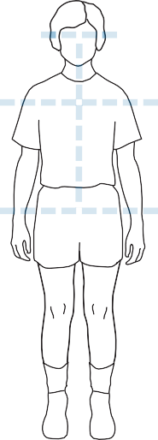
1. A Review of Good Posture: How to Find ‘Neutral Spine’

Good posture ensures your spine is in the correct position. We call this position ‘neutral spine’. Before starting an exercise, always find neutral spine as follows:

Neutral spine standing or sitting
  - Stand with feet shoulder width apart, or sit on both sitting bones evenly
  - Bring your spine to neutral by tightening stomach muscles to tuck your bottom in
  - Imagine a string attached to the top of your head is being pulled up on
  - Bring shoulder blades together and down to your back
  - Tuck your chin slightly so that your ears are in line with your shoulders


© Vancouver Coastal

2. Gentle Neck Range of Motion Exercises

Remove your collar and perform the following neck range of motion exercises gently and as pain allows.

Flexion

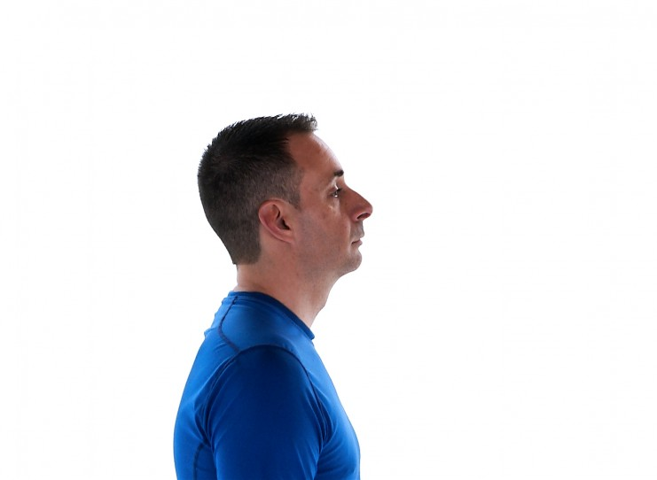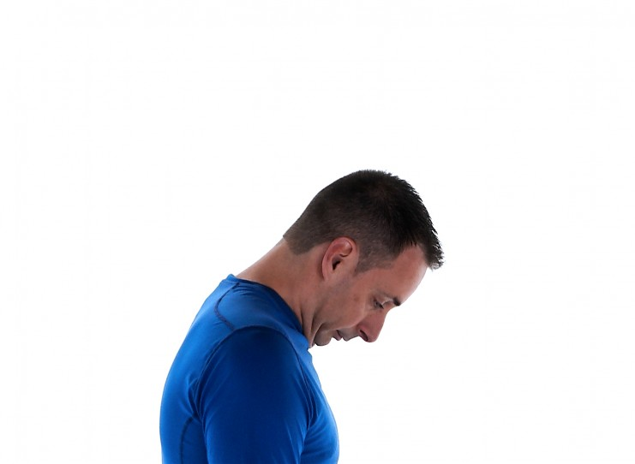

Stand or sit tall.

Slowly bend your chin to your chest to look down toward the floor.

Return to the neutral position.

Repeat 3 times.

(PhysioTec)

Side Bending

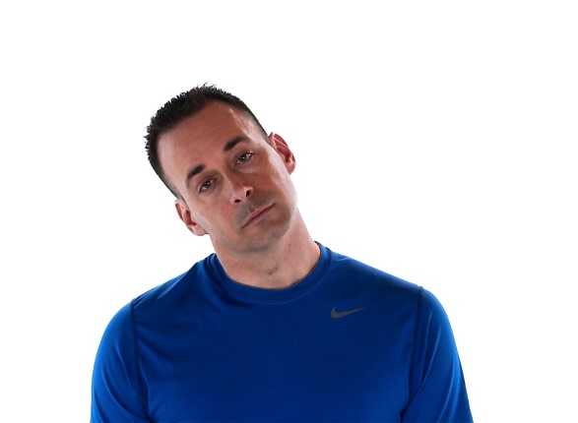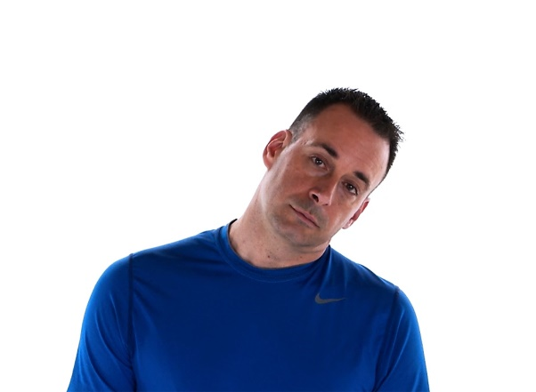

- Stand or sit tall.
- Without turning the head, slowly tilt your head sideways to bring your ear to your shoulder.
- Return to the neutral position and repeat 3 times each direction.
(PhysioTec)
- Rotation
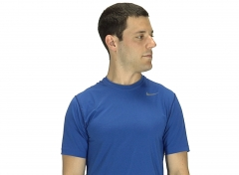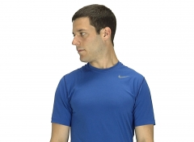

- Sit or stand in a good upright posture.
- Nod your chin just to neutral.
- Keeping the chin nod, turn your head to one side, as far as you can go while still maintaining the pure motion.
- Do not allow the chin to poke, the head to tip back, or the head to tilt to the side.
- You may need to do this in front of a mirror to check the movement pattern.
- Keep the eyes leveled.
- Return to neutral position and repeat 3 times in each direction.
(PhysioTec)

3. Walking Program
Walking is one of the best exercises to help you recover from the surgery. When walking, always make sure you adopt a good posture with a neutral spine.
  - Start with frequent, short walks on level ground
  - Each day increase the amount of time you spend walking
  - As your walks get longer, cut back the number of walks per day. This will allow you to increase your walking time and prevent getting too tired or sore
  - Make sure you wear comfortable clothing and footwear such as good running shoes
  - If nervous or unsure when walking outside, walk with someone
  - If walking with a walker, cane, or poles, try to stand as erect as you can. Keep the walker close to you

Progression of Exercises
- Before returning to sports and other physical activities, obtain permission from your surgeon
- When your surgeon allows you to return to your regular activities, we recommend that you see a physiotherapist to progress this exercise program
- Book an appointment at a Physiotherapy clinic after you follow-up with your surgeon to help you build your strength, flexibility and improve the stability of your neck.

Acknowledgement to Vancouver Coastal Health Authority and PhysioTec

